**EXERCISE 06**

**TASK I**

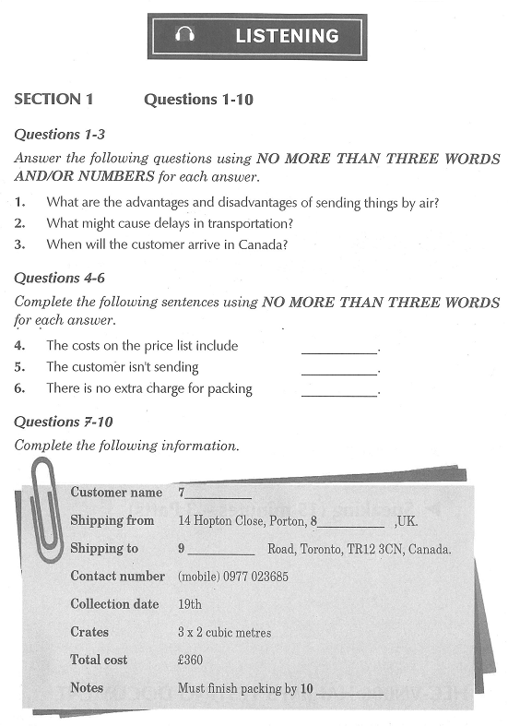

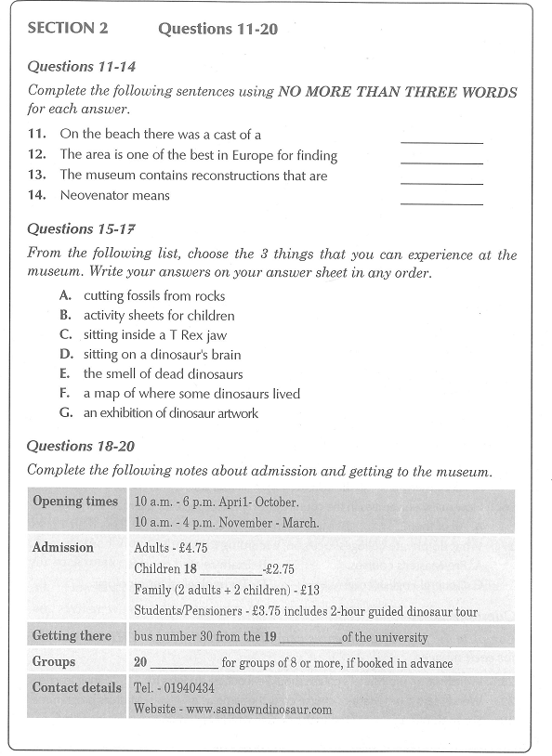 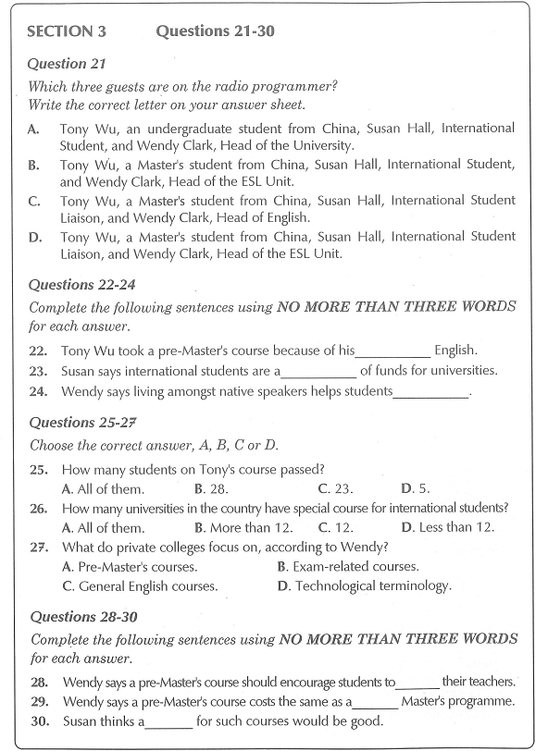 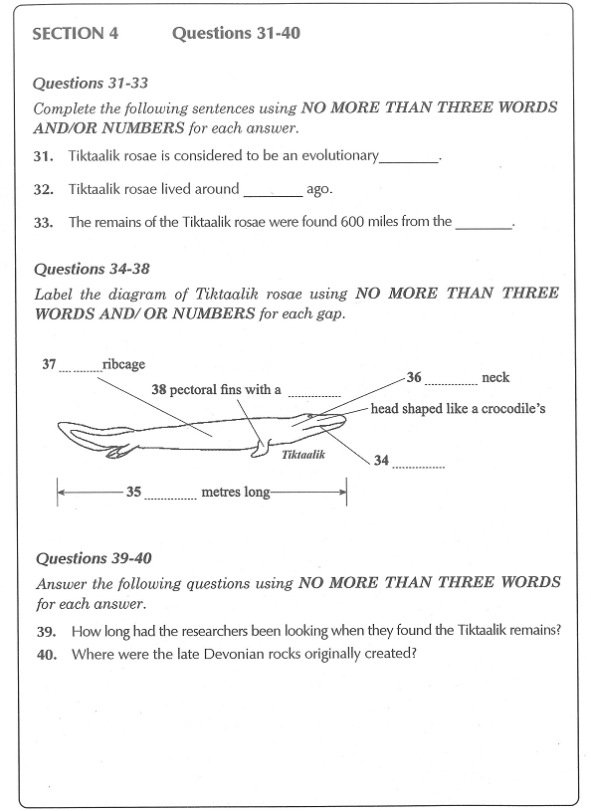

**TASK II: GAP-FILLING**

**SECTION 1**

Salesman: Good afternoon, madam. How may I help you?

Customer: Good afternoon. I'd like to ship some **[............possessions.....................]**to Canada and was hoping you could answer a few of my questions.

Salesman: Certainly. Please take a seat. Where exactly are you going to ship the goods?

Customer: To Toronto. I'm taking a job there at the end of next month.

Salesman: Right. We can ship your possessions by air or by sea and land. Shipping by air is faster but is obviously more **[.......expensive..........................]**.

Customer: I understand. That's what I **[...........expected......................]**. If I want the things there by - **[.......the 20th (THE 25TH) ..........................]**of next month, do I still have time to send them by sea?

Salesman: I'll just check the **[.........schedules........................]**... Yes, if your possessions start their **[........journey.........................]**by the 26th of this month at the latest, they'll be in Toronto by the 25th of next month. However, I would **[............recommend.....................]**that you send them earlier if possible because there are sometimes **[............delays.....................]**due to **[.............logistics....................]**or weather conditions.

Customer: Yes, of course. I was thinking of sending them on the 20th or **[..........THEREABOUTS.......................]**.

Salesman: That’s great. There's a cargo ship leaving on the **[..............21st ...................]**. Would it be possible to send your possessions on the 19th? It can take two days to get the items to the port and to clear customs at this end.

Customer: Yes, I guess that would be OK.

Salesman: In that case, your possessions should arrive on or around the 19th of next month, though, as I said, there are sometimes delays. Is that OK for you?

Customer: That's **[..............perfect...................]**! That's the very day 1 arrive in Canada. It could be a bit **[..........hective (HECTIC).......................]**though. Anyway, I won't need my things **[.........immediately........................]**, so d short delay won't cause any problems.

Salesman: Don't worry. You won't be able to take **[............the delivery.....................]**of your possessions that day because of **[............customs.....................]**checks Those usually take a couple of days. Will you be packing everything yourself or would you like us to take care of that for you?

Customer: I'd prefer to have your **[.......employees..........................]**do it. As you can imagine, I’m rather busy at the moment.

Salesman: And you'll want us to **[.........arrange........................]**delivery to your new home in **[..................Canada...............]**rather than leaving the items at the **[..........warehouse.......................]**in Toronto, right?

Customer: Yes, please. I know that **[.........DOOR-TO-DOOR........................]** delivery costs more, but it's so much more **[......convenient...........................]**.

Salesman: OK then. Here's a price list. The prices include tax and **[.........insurance........................]**. As you can see, the price depends mainly on the **[.........dimension........................]**of the crates and the number of crates rather than their weight. However, we do add an extra charge for **[..........particularly.......................]**heavy items. Do you intend to ship any furniture?

Customer: No, nothing like that-just books, clothes, a few small **[..........electrical.......................]**items and a few ornaments.

Salesman: If there are any **[..........FARGILE.......................]**items, such as glass **[............ornaments.....................]**, I can make a note for our packers. There's no extra charge for such items.

Customer: Thank you. There is a little **[...........glassware......................]**. Using plenty of **[...........bubble......................]**wrap should ensure it arrives intact. Would you recommend three of the smaller sized crates or one of the very large ones?

Salesman: For ease of handling we normally suggest that customers use the smaller sized ones. The large ones appear cheaper, but if they **[.........exceed........................]**a certain weight they incur an extra charge. We generally only use them for large **[...........light weight......................]**items or furniture.

Customer: I see. I think that three of the smaller crates measuring two cubic metres should do the trick.

Salesman: OK. In that case, the total price will be **[.........360 pounds........................]**. Is that OK?

Customer: Yes, that's fine. Thank you. Can I pay by credit card? I have **[..........master..express.....................]**.

Salesman: Of course. I need to take down a few details. Could I take your name, please?

Customer: My given name is Debra -DEBRA- and my surname is Whealing - WHEALING.

Salesman: And your address?

Customer: 14 Hopton Close. The postcode is **[.......PT62JA..........................]**.

Salesman: And the address where we should ship your possession to in Canada?

Customer: 42a Lake View Road in the **[........district.........................]**of Victoria.

Salesman: Is "Lake View" written as one word or two?

Customer: Two. The postcode is **[.............TR123CN....................]**.

Salesman: Do you have a mobile phone?

Customer: I do. The number's **[............0977023685.....................]**.

Salesman: Thank you. Right, then. Our packers will arrive on the morning of the 19th. I'm **[...........afraid ......................]**I can't give you an exact time, but it should be around 10 o’clock, **[............depending.....................]**on the traffic.

Customer: Thank you. As long as they finish before 1 o'clock. I don't mind.

Salesman: I'll make a note of that. Right, I'll just deal with the **[......payment...........................]**...

**SECTION 2**

Presenter: Good morning, everyone. I'm very happy to be here to give you a **[.......brief..........................]**introduction to some of the places you can visit in the **[...........locality......................]**of your university. I hope that you can take some time out from your studies to pay a visit to at least a few of them. First, I'd like to tell you about Dinosaur Isle and Fossil Walk. It's one of my **[..........favorite.......................]**days out.

I remember my first visit there. We were walking along a beautiful **[..............sandy beach...................]**when our **[........PALAEONTOLOGIST.........................]**, guide stops suddenly and points at a rock perhaps **[.............60 cm....................]**across. "That." he savs. "is the cast of a **[.............dinosaur’s footprint....................]**." At first I thought he wras joking, but he goes on to point out the three vast toes and to explain that this stone was **[.............MOULDED....................]**in the footprint of an Iguanodon some **[......(125)...375 million........................]**years ago. From the size of the "foot", he adds, this particular **[.................................]**biped would have been about **[.........8 meters........................]**long and perhaps ‘2.5 metres tall to the hip. This area is one of the most **[...........PROLIFIC......................]**and accessible sites in Europe for dinosaur **[.......fossils..........................]**. Bits of bone are regularly found on the beaches and the Dinosaur Isle **[...........museum......................]**has a collection of international importance-and is thoroughly family-friendly to boot.

At the museum, you can walk back in time, via the last Ice Age and the Eocene to the late **[...........CRETACEOUS......................]**to the heyday of the dinosaurs, to which the main hall is **[.........dedicated........................]**. The information is accessibly presented and there is enough to **[..........satisfy.......................]**even the most ardent "dinophile" of any age. The collection sensibly majors on the dinosaurs that once **[...........ROAMED......................]**this area, with full-size re-**[......construction...........................]**as well as fossils ranging from huge **[..........VERTEBRAE .......................]**to toothed jaws and long leg bones. Many of the **[.........special.(SPECIMENS).......................]**were found by amateur fossil hunters, including two families on holiday here in the **[........1970s.........................]** who found some bones on a beach in the **[.........south west........................]**of the island; they turned out to belong to an **[..........IGUANODO.......................]**and another completely new dinosaur, **[.............subsequently....................]**called Neovenator. meaning "new hunter".

On my first Fossil Walk a piece of dinosaur rib bone was found, and the day before, four dinosaur bones were **[.........discovered........................]**as well as a large **[..........prehistorIC.......................]**crocodile tooth. Even if you are not lucky enough to find bits of dinosaur, there are **[.........110 million........................]**-year-old shells and **[........fossilized.........................]**wood to be collected. Our guide was not only extremely **[.......knowledgeable..........................]**but also endlessly patient as he identified a steady stream of **[........sandstone.........................]**and flint with a few fossils thrown in.

Back at the museum there is stacks for kids to do: three different activity sheets and lots of interactive **[.......exhibits..........................]**. The touchy-feely game was a big hit. It revealed a **[..........source of part(SAUROPOD) .......................]**claw, fossilised dinosaur poo. It's great fun for the kids to make their parents feel this! And then there is the cast of a Tyrannosaurus' **[........brain.........................]**which is, remarkable for its **[.........smallness........................]**Smells from the dinosaurs' world were much enjoyed too-rotting corpse, **[.........PINE FOREST........................]**, swamp and carnivore breath. The last was particularly **[...........Yucky......................]**in my opinion.

An interactive map shows where the **[...........locality......................]**five main dinosaurs were found, along with a second map indicating their global spread. Upstairs, there is a **[.............reconstruction....................]**of the Sandown pterosaur, which was **[..........on earth.......................]**close to the museum and its fossils, along with information about the area’s own **[......**Tyrannosaurus**...........................]**, discovered in 1995-about half the size of T Rex and called Eotyrannus Lengi-as well as loads of **[.............dinosaur.. ..................]**art activities.

Unfortunately, there are currently no **[.............refreshment....................]**available on site, but there is a mini-golf course next to the museum which has a cafe. The museum is fully **[..........will cherish.......................]**accessible. Let me just give you the **[.........given........................]**details. Dinosaur Isle and Fossil Walk are both open daily 10 a.m. to 6 p.m., April to October, and 10 a.m. to 4 p.m., November-March. Adult tickets are **[..........4.75 pounds.......................]**, children under 15 pay **[...........2.75 pounds......................]**. There’s also a family ticket, available for two adults and two children, which costs £13. Students and **[.........retireries........................]**pay £3.75. The two-hour guided dinosaur walk is included in the **[.................ticket price................]**.

Finally, I'll let you know how to get there. Despite the name, Dinosaur Isle isn't actually an island. From the university, take bus number 30. which I believe stops right outside the main gate. Is that right? Yes? Thank you. The bus stops almost directly in front of the **[..........museum.......................]**, and you can't miss that because it has a big **[...........plastic......................]**T Rex outside! If you're going as a group of more than eight, please telephone in advance. A group **[.........discount........................]**, is available if you do. but not if you arrive **[..........unannounced.......................]**. The phone number is 019 40434, and there's a website too-www.sandowndinosaur.com.

**SECTION 3**

Interviewer: Welcome to our University Radio **[.........program........................]** entitled "Leaping the Language Barrier". Mv guests today are Tony Wu. a Master's student from China. Susan Hall. International Student Liaison, and Wendy Clark. Head of the ESL Unit here at the university. Tony, you're starting your Master's degree in a few weeks, aren't you?

Tony Wu: Yes, I am. I'll be taking a Master’s in Computing. Like many **[..........oversea.......................]**students, I found the selection process tough. Making the **[...........transition......................]**from undergraduate studies to **[.............postgraduate....................]**research is hard enough for a native speaker, but mv lack of **[..fluency ...............................]**in English was a bigger hurdle. So. I decided to take a pre-Master's course.

Interviewer: Susan, are these courses popular?

Susan Hall: Not at the moment, but each year, over **[...........one hundred thousand......................]**overseas students apply to study for a **[.........postgraduated........................]**degree in this country. Many of these students, like Tony, need to work on their English to get the maximum **[.............benefit....................]**from their time here. Paying full fees, these students represent a **[................significant.................]**source of income for the universities. As a result, a growing number of universities and **[............private colleges.....................]**are offering foundation or pre-Master's courses. The pre-Master's courses are **[.......designed..........................]**to bridge the gap between undergraduate studies and a postgraduate degree taught in English.

Tony Wu: That's right. I won my place on the Master's course after **[........attending.........................]**a nine-month pre-master’s programme at the International **[..........Foundation.......................]**College, a private language and study skills school **[................proved.................]**by universities in this country.

Interviewer: Wendy, you're an ESL professional. How useful are these courses?

Wendy Clark: Very useful indeed. As Susan said, many students come here with some English, but not really enough lo take full **[...........advantage......................]**of having an education in an English-speaking country. Pre-Master’s courses bring language **[............pro.....................]**up to a more acceptable level. Students develop language skills through classroom **[.............interaction....................]**and bv being part of the wider community, living among native English speakers.

Interviewer: Tony, how successful were the other students on your course?

Tony Wu: The IFC pre - Master's course started in **[..........January.......................]**with 28 students, all from China. All but five gained places on **[............university.....................]**Master's courses. The IFC was very happy with the success rate.

Interviewer: Wendy, Tony didn't do his course here, but this university does have a pre-Master's course, doesn't it?

Wendy Clark: Yes, it does. In this country, at least a **[....................dozen.............]**universities now run courses specially designed to cater for the needs of students from overseas regions-**[...........particularly......................]**Russia, Japan, China, East and South Asia. On top of that, **[.........private colleges........................]**are starting to enter the market, although most stick to what they do best-improving students’ English language **[...........test score......................]**. Last year, we prepared 80 foreign students-mostly from China, South East Asia, Iran and the former Soviet **[............republic.....................]**-for masters degrees at universities in this country. Studied over an **[........academic.........................]**year, the course is demanding. Students from a range of **[............disciplines.....................]**are taught by a subject **[.........specialist........................]**, with an English language teacher working **[........alongside.........................]**to review students' **[..........comprehension.......................]**and written work. The course culminates in a mini **[.........dissertation........................]**prepared over four months.

Interviewer: Did you find that difficult, Tony?

Tony Wu: I certainly did!

Wendy Clark: I believe that a pre-Master's course should do a lot more than boost language skills. It's also about preparing students from different **[.........culture........................]**backgrounds to succeed in the academic world. We prepare them to look at a variety of sources, **[.........analyze........................]**the pros and cons, put forward their own ideas, **[........challenge.........................]**their tutors and take part in **[........rigorous.........................]**discussion.

Interviewer: Wendy, has the course run at this university been successful?

Wendy Clark: The results here speak for **[.........themselves........................]**. The one-year pre- Master's programme has a **[..........ninety percent.......................]**success rate and a **[.................................]**of students go on to Harvard, Yale, Oxford and Cambridge as well as other **[...........prestigious......................]**institutions. However, at **[........nine thousand dollars.........................]**, the course fee is on a par with the full fee for a Master's programme itself.

Interviewer: Susan, do you have any reservations about these **[..............programs...................]**?

Susan: Not here at our university, but I am unhappy at what I see as a lack of control over the **[.................................]**of pre-Master's programmes. Some form of external **[........validation.........................]**is needed, as there is no universal recognition of the quality of such courses. There is a **[...........benchmark......................]**system for access to higher education courses for **[...........domestic......................]**students, but so far there is no **[...nation-wide..............................]**benchmark for foundation courses for international students.

Interviewer: Thank you all very much. Next week, I'll be talking to ...

**SECTION 4**

Welcome everybody. My name is Derek Fisher and I'll be taking you through this talk on a **[..........truly.......................]**amazing **[............discovery.....................]**made by my team of **[..........researchers.......................]**last j'ear. As I'm sure you know, we discovered Tiktaalik **[...................Rosae..............]**, a so-called "missing link" in the **[....evolutionary.............................]**process-a fish that walked on land. We made this **[.................................]**discovery in the Canadian Arctic. I should **[..........enphasize.......................]**right at the beginning that I do not have any **[......................evidence...........]**to suggest that this was the only such fish to make the leap from the sea to the land. I think that further **[..........discovery.......................]**may await researchers.

Anyway, the fossil discovery **[......eliminate...........................]**a chapter in the history of life on Earth that was **[....essential.............................]**to the ultimate emergence of human beings. This is an **[.........impression........................]**of Tiktaalik roseac, which, we believe, lived about **[.........375 million........................]**years ago. As you can see, it has features that blur the **[........distinction.........................]**between fish and **[......t...........................]**limbed creatures. The fossils that we found on Ellesmere Island, **[...............600 miles..................]**from the North Pole, are a fine example of evolution in action. They have allowed us to **[..........free.......................]**a process of adaptation to land that took tens of millions of years, and which made possible the development of all the **[......mammals...........................]**, birds, reptiles and **[.................................]**that have existed since.

Without creatures such as Tiktaalik there would have been no dinosaurs, no **[.................................]**mammals and none of the **[.................................]**such as Australopithecus **[.................................]**and Homo erectus that started the human family tree. This animal represents the **[............transition.....................]**from water to land-the part of history that includes **[..........ourselves.......................]**. It's as much a part of our history as, say, Australopithecus **[.................................]**. Now, you can see those teeth. From that, it is clear to us that Tiktaalik roseae was a predator with **[.......sharp..........................]**teeth and a head shaped like a **[.........crocodile........................]**that grew to between four feet and nine feet-that's between 1.2 metres and 2.7 metres long for those of you using the **[.............ma....................]**! We named it after **[...........consultation......................]**with elders from the Inuit people, who are native to the region, who suggested their word for "large shallow- water fish". The second part of the name **[.................................]**the person who funded our research, but wishes to remain **[........enormous.........................]**.

It had several remarkable **[.................................]**features that show it was capable not only of wading in shallow water, like slightly earlier fish on the cusp of the move to land, but also of **[...........supporting......................]**itself outside the water in the manner of **[........fulling.........................]**animals or tetrapods. This is where Tiktaalik truly blurs the **[............boudary.....................]**between fish and land animals. This animal is both fish and **[.................................]**. At first, we jokingly call it a "fishapod". Unlike fish, it had a clearly defined neck and a strong **[............ribcage.....................]**that would have enabled it to stand outside water. Its **[.................pectoral................]**fins had a wrist joint, which enabled it to **[............crawl.....................]**on the ground. This wrist is **[..........sufficiently.......................]**similar to that of later animals, including human beings, to suggest that Tiktaalik or something very like it was an **[................ancestor.................]**of all subsequent land animals. However, we cannot be sure of that. When we talk about the fish's wrist, we're talking about the origin of parts of our own wrist. It is **[........absolutely.........................]**clear from Tiktaalik's **[..........skeleton.......................]**that it could support itself in **[.................................]**water or on land. This is why it represents a critical early phase in the **[............evolution.....................]**of all limbed animals, including humans.

WP found the Tiktaalik fossils in **[............2004.....................]**after a five-year search of a rock formation on Ellesmere Island, one of the large islands that **[..........comprises.......................]**the north of Canada. This site was **[...........chosen......................]**because it was-or more **[............exactly.....................]**the rocks were-laid down during the late Devonian period, between **[...............390..................]**million and **[...........365......................]**million years ago, when the transition of fish from sea **[...........creatures......................]**to creatures that could survive on land is known to have taken place. It may **[.........surprise........................]**you to know that although the rocks are now within the Arctic Circle, in the late Devonian they lav close to the Equator. We, as **[..................individual...............]**humans, don't notice plate movements because **[................dramatic.................]**changes can only be seen over millions of years, but the **[.................................]**as we know them today have moved **[.........considerably........................]**and will continue to do so. This exciting discovery is **[..............providing...................]**a much deeper understanding of this evolutionary **[.................................]**. Previous fossils representing this evolutionary event have really been fish with a few land **[.........characteristics........................]**, or land vertebrates with a few **[.................................]**fish characteristics. These fossils show an animal that sits bang in the middle.

Now, let's move on to ...